|  |  |  |  |  |  |  |
| --- | --- | --- | --- | --- | --- | --- |
| VILNIAUS KOLEGIJA  UNIVERSITY OF APPLIED SCIENCES  FACULTY OF ELECTRONICS AND INFORMATICS  Image result for viko logo | | |  | | | VILNIUS COLLEGE  Image result for viko logoFACULTY OF ELECTRONICS AND INFORMATICS |
|  | | |  | | |  |
| **INFORMATION SYSTEMS** | | |  | | | **INTRODUCTION TO INFORMATICS** |
| PRACTICAL ASSIGNMENT  The System Requirements Specification  6531BX028 PI18E | | |  | | | PRACTICAL ASSIGNMENT  SPOTIFY USER MANUAL  6531BX028 PI18E |
| STUDENT | DŽIUGAS PEČIULEVIČIUS | STUDENT | | DŽIUGAS PEČIULEVIČIUS |
| (SIGNATURE)  11/11/2019 | | |  | | | LECTURER |
| LECTURER | TATJANA LIOGIENĖ | (SIGNATURE)  10/17/2018 | | VIRGILIJUS KUKLIERIUS |
| (SIGNATURE)  11/11/2019 | | |  | | | 2018 |

2019

**TABLE OF CONTENTS**

INTRODUCTION 4

A. PROBLEM AND A SOLUTION 5

B. SYSTEM USERS 5

C. FUNCTIONAL REQUIREMENTS 5

D. UML USE CASE DIAGRAM 6

E. REQUIREMENTS TRACEABILITY MATRIX 7

F. PRIMARY AND SECONDARY SCENARIOS 7

CONCLUSION 10

**TABLE OF FIGURES**

Figure 1 - use case diagram 6

Figure 2 - traceability matrix 7

Figure 3 - log-in / log-out use case 7

Figure 4 – Send Plan use case 8

Figure 5 - Check Storage / Send Alert use case 8

Figure 6 – Good Received Confirmation use case 9

Figure 7 - Make item orders 9

# INTRODUCTION

**Program used for charts**

Website: draw.io

**Goal**

Goal is to prepare a system Requirements specification document.

**Tasks**

* Describe a problem from the first practical work and offer a solution to fix it.
* System users must be listed and described.
* Create a list of functional requirements for the new information system.
* Create UML Use Case diagram, fill requirements traceability matrix and describe each use case primary and secondary scenarios.

# PROBLEM AND A SOLUTION

In the first practical work uncovered problem was that all the messages, plans and orders are being sent on paper with items itself. This way it is easy to lose information and hard to keep track of the of items and their numbers. As a solution it would be a great idea to create a system where all orders and item and product numbers would be entered and kept in track.

# SYSTEM USERS

1. **Office department manager** – responsible for receiving orders and sending a plan to material warehouse on distributing items across manufacturing department.
2. **Raw-material warehouse** manager – receives plan and distributes material according to plan, if anything is missing – new items will be ordered by sending an order to the office department.
3. **Manufacturing department manager** –responsible for assembling, packaging, testing and labeling of the computers. Receiving material and ordering parts that are missing.
4. **Product warehouse manager** – Responsible for receiving all working items and storing them.

# FUNCTIONAL REQUIREMENTS

1. System should let every manager log-in into and log-out of their own accounts.
2. The system should have functionality to let the office manager to send a full plan with item numbers, item identification numbers.
3. The system should let leave a note for any specific requests to the Raw-material warehouse manager and Product Warehouse manager.
4. The system should let departments to receive plans and material information that are specified above when they arrive and confirm the goods
5. Should let department managers to place orders of new items if needed and send the request to the office.
6. The system should check storage and send an alert to a manager when items are running low and more of them need to be ordered.

# UML USE CASE DIAGRAM

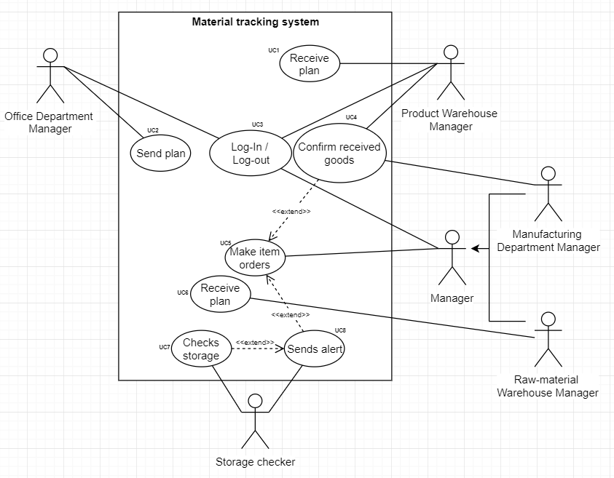

Figure 1 - use case diagram

# REQUIREMENTS TRACEABILITY MATRIX

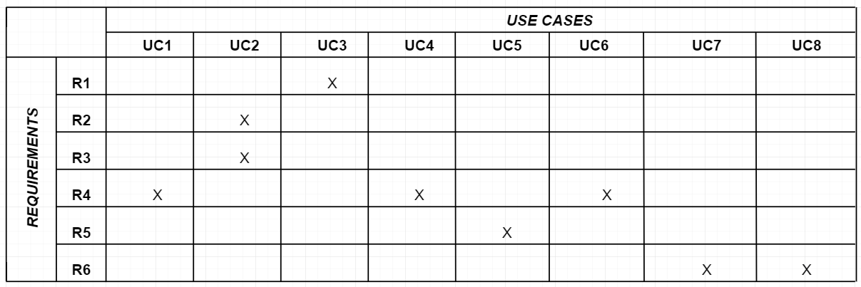

Figure 2 - traceability matrix

# PRIMARY AND SECONDARY SCENARIOS

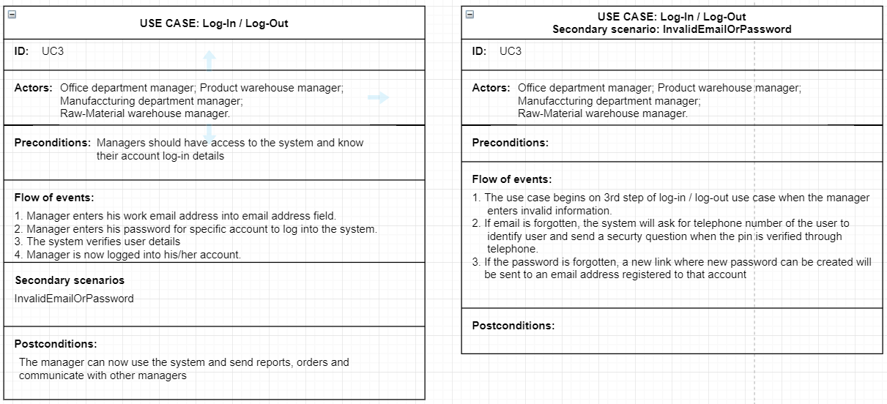

Figure 3 - log-in / log-out use case

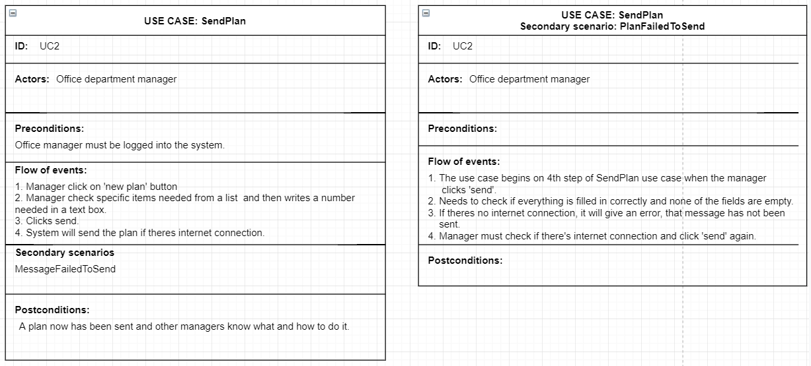

Figure 4 – Send Plan use case

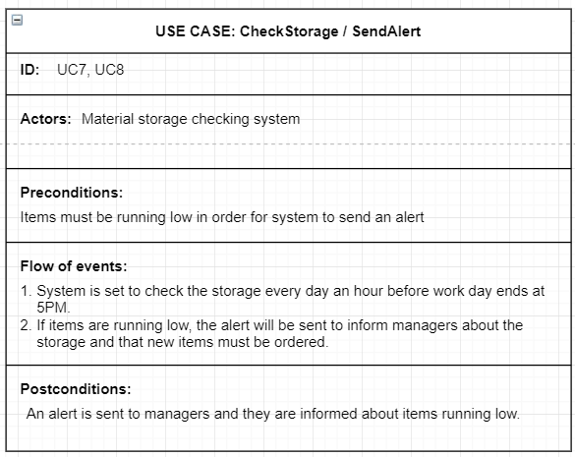

Figure 5 - Check Storage / Send Alert use case

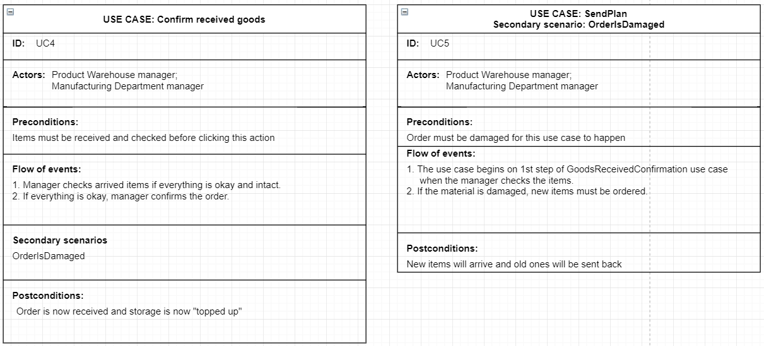

Figure 6 – Good Received Confirmation use case

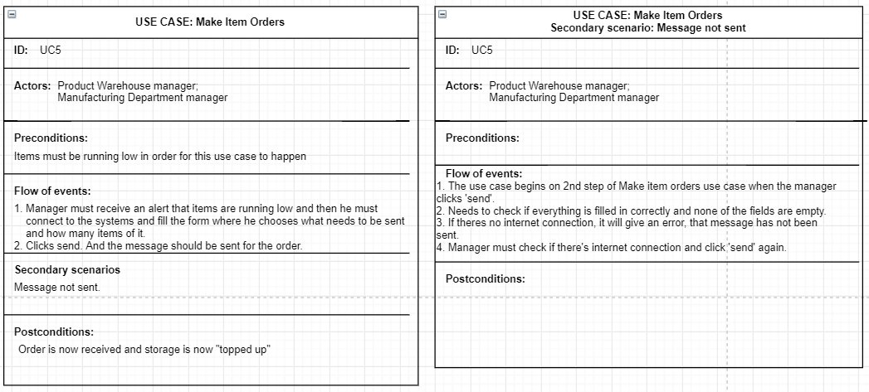

Figure - Make item orders

# CONCLUSION

In conclusion, the automization system makes life easier for managers, so they don’t have to spend time checking and counting how many items are there left and if more need to be ordered. The system will track the item numbers in store and will send alerts to managers if any of the items is running out and more need to be ordered.